Date | 17 February 2026
Team ID | LTVIP2026TMIDS85401
Project Name | Strategic Product Placement Analysis
Maximum Marks

PROJECT REPORT

Strategic Product Placement Analysis
1. INTRODUCTION

1.1 Background
In today’s competitive retail environment, product placement plays a crucial role in influencing customer purchasing behavior and maximizing sales performance. Retail stores generate massive volumes of transactional data across multiple locations, categories, and shelf positions. However, much of this data remains underutilized due to its scattered structure in spreadsheets and POS systems.
Retail managers, category heads, and merchandising teams require clear insights into how product positioning (eye-level shelves, end-cap displays, checkout counters, promotional zones) impacts revenue and profitability. Without interactive analytics tools, analyzing these patterns becomes time-consuming and inefficient.
Data visualization tools such as Tableau transform raw retail sales and placement data into interactive dashboards, enabling stakeholders to monitor trends, compare store performance, identify high-performing placement zones, and make data-driven merchandising decisions.

1.2 Project Overview
Strategic Product Placement Analysis is a Tableau-based data visualization project designed to analyze and present retail sales performance based on product placement strategies across stores and time periods.
This project focuses on:
- Store-wise sales distribution
- Placement zone performance comparison
- Monthly and quarterly sales trends
- Identification of high-performing and underperforming shelf areas
- Year-over-Year (YoY) sales comparison
- Interactive storytelling using Tableau Story
The dashboard converts raw CSV retail datasets into actionable visual insights that support strategic merchandising decisions.
1.3 Objectives
The main objectives of this project are:
- To design an interactive product placement analytics dashboard
- To analyze sales performance across stores and placement zones
- To identify seasonal and peak sales periods
- To compare Year-over-Year sales growth
- To present insights using story-based visualization
- To publish dashboards for web accessibility
2. IDEATION PHASE
2.1 Problem Statement
Retail organizations often lack a centralized, interactive platform to analyze how product placement impacts sales performance. Sales data stored in static Excel sheets limits the ability to identify trends, evaluate shelf effectiveness, and optimize store layouts. This creates inefficiencies in merchandising decisions and revenue planning.
2.2 Target Users
The primary users of this dashboard include:
- Retail Managers
- Merchandising Teams
- Category Managers
- Marketing & Promotions Analysts
- Senior Executives
2.3 Empathy Map
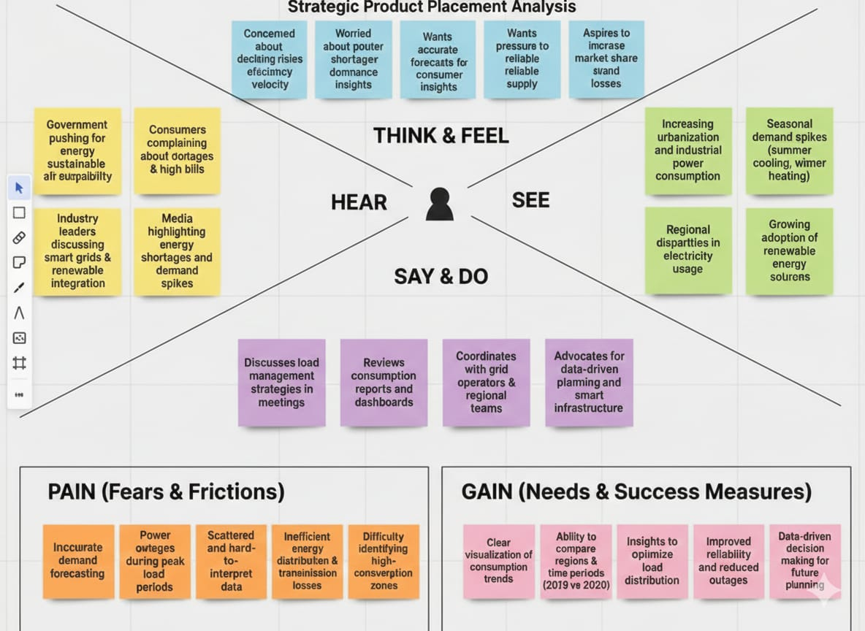
Data driven decision making for future planning
- THINK & FEEL
- Concerned about declining sales in certain categories
- Unsure whether shelf placement affects product visibility
- Feels pressure to improve store revenue
- Wants clear, reliable data for decision-making
- Aspires to optimize layout for better customer experience
- HEAR
- Management demanding revenue growth
- Customers responding to promotional displays
- Marketing teams discussing campaign performance
- Competitors adopting smarter merchandising strategies
- SEE
- Uneven sales performance across stores
- Seasonal demand spikes
- Underutilized shelf spaces
- High sales from promotional or eye-level displays
- SAY & DO
- Reviews sales dashboards regularly
- Conducts merchandising meetings
- Discusses layout optimization strategies
- Plans promotional placement changes
- PAIN (Fears & Frictions)
- Poor visibility of product performance by placement
- Scattered sales data
- Ineffective shelf utilization
- Difficulty identifying underperforming zones
- GAIN (Needs & Success Measures)
- Clear visualization of placement effectiveness
- Ability to compare stores and time periods
- Data-backed layout optimization
- Improved revenue and profitability
- Faster decision-making
3. REQUIREMENT ANALYSIS
3.1 Functional Requirements
- Interactive filters (Store, Region, Category, Placement Zone, Year, Quarter)
- Placement zone performance charts
- Monthly & quarterly sales trend analysis
- Year comparison visuals (YoY growth)
- Story-based dashboard navigation
- KPI summary indicators (Sales, Profit, Growth %)
3.2 Non-Functional Requirements
- Dashboard loading time under 5 seconds
- Responsive layout for executive presentations
- Accurate KPI calculations
- Secure publishing via Tableau Server/Public
- Scalable data structure for future expansion
3.3 Data Requirements
The dashboard uses retail sales and placement datasets containing:
- Store Name
- Region
- Product Category
- Placement Zone
- Monthly Sales
- Quarterly Totals
- Year (e.g., 2022 & 2023)
- Total Records: 1000+ entries

4. SYSTEM DESIGN
4.1 Data Flow Diagram
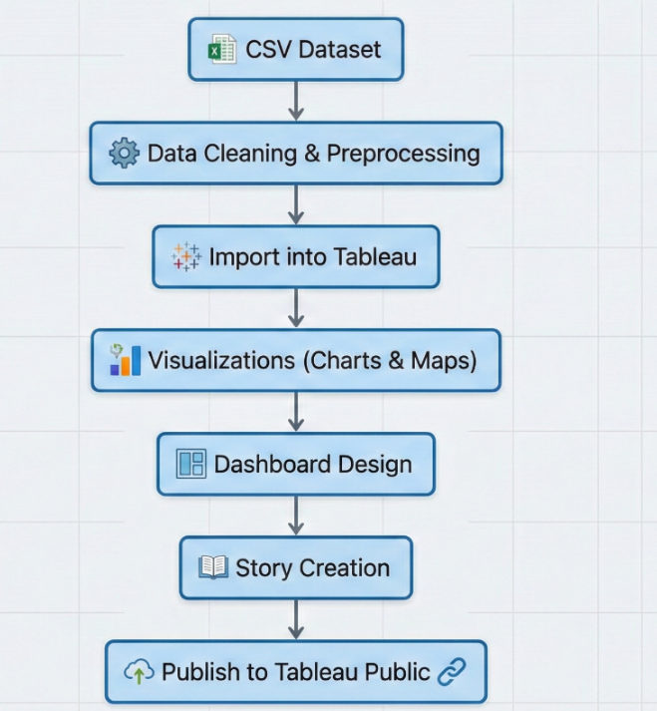
4.2 Solution Architecture
- User Interface Layer
- Tableau Web Dashboard
- Interactive filters and KPI cards
- Application Layer
- Tableau Calculated Fields
- Filtering, aggregation, and business logic
- Data Layer
- CSV retail datasets
- Optional cloud storage
- Deployment Layer
- Tableau Public / Tableau Server
- Embedded via HTML iframe
5. PROJECT PLANNING & SCHEDULING

Phase | Task | Time (Days)
Phase-1 | Data Collection | 1
Phase-2 | Data Cleaning & Preprocessing | 2
Phase-3 | Visualizations Development | 2
Phase-4 | Dashboard & Story Creation | 2
Phase-5 | Performance Testing | 1
Phase-6 | Web Integration & Publishing | 1
Phase-7 | Report & Documentation | 3

6. FUNCTIONAL AND PERFORMANCE TESTING
6.1 Performance Testing
- Data Loaded: 1000+ retail records
- Filters Used: Store, Region, Category, Placement Zone, Year, Quarter
- Calculated Fields: YoY Growth, Placement Contribution %, Profit Margin
- Visualizations: 12–15
- Result: Smooth performance with response time under 3–5 seconds
7. RESULTS
Output Screenshots (Examples)
- Avg Sales Volume vs Product Category
- Avg Sales Volume vs Product Category:
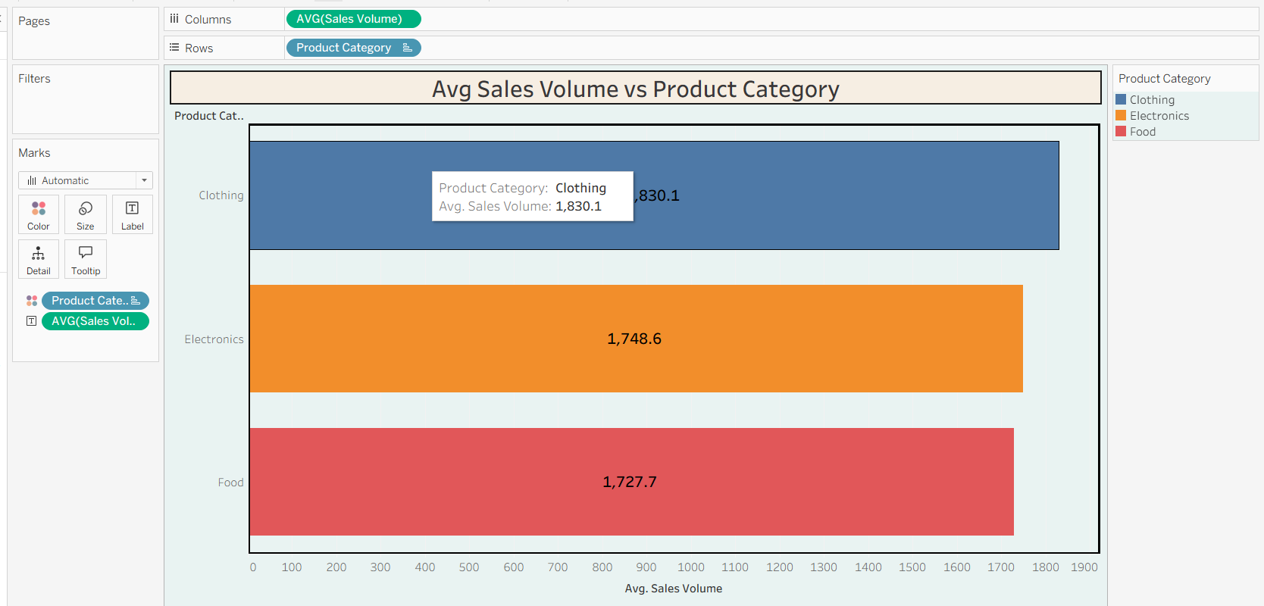
- Product Category vs Price
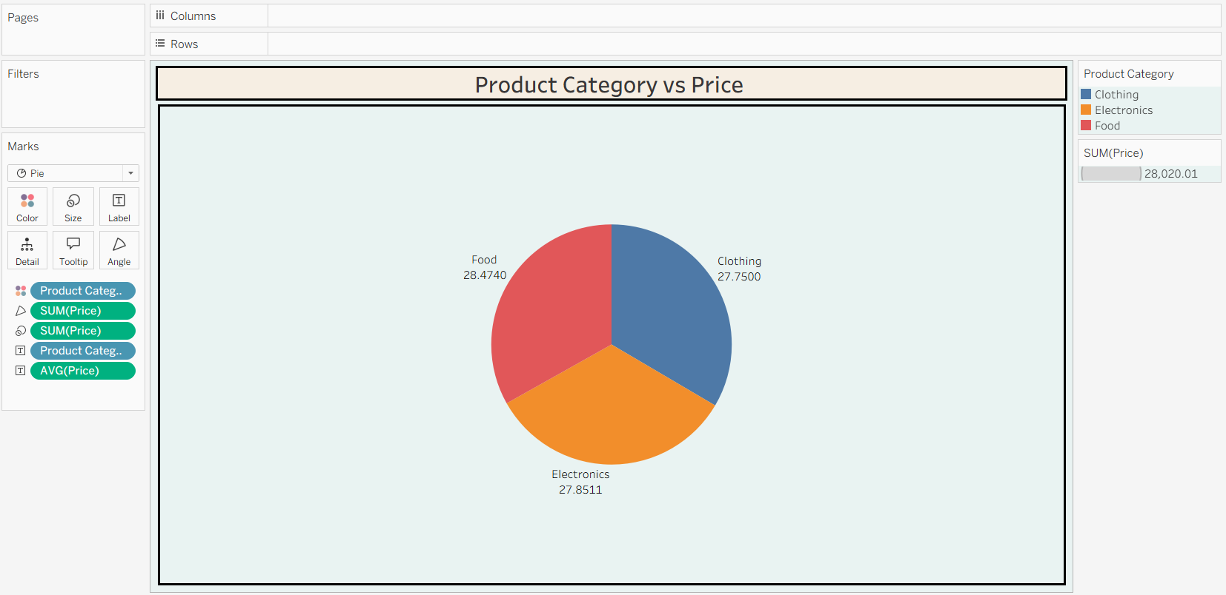
- Consumer Demographics vs Sales Volume
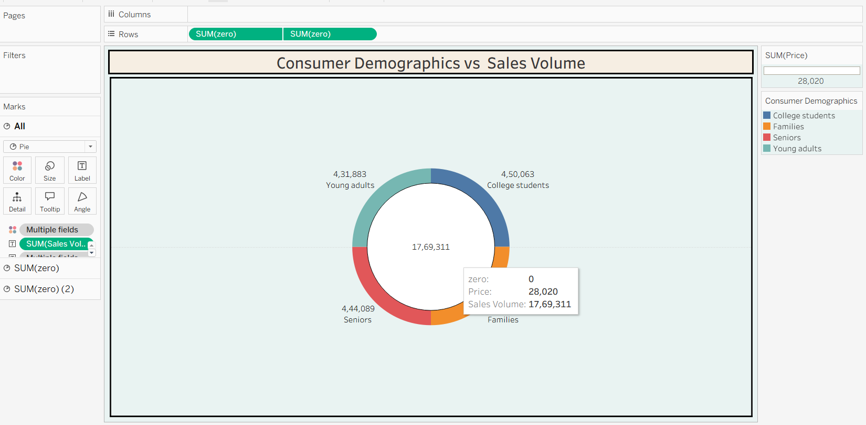

- Foot Traffic by Avg Sales Volume
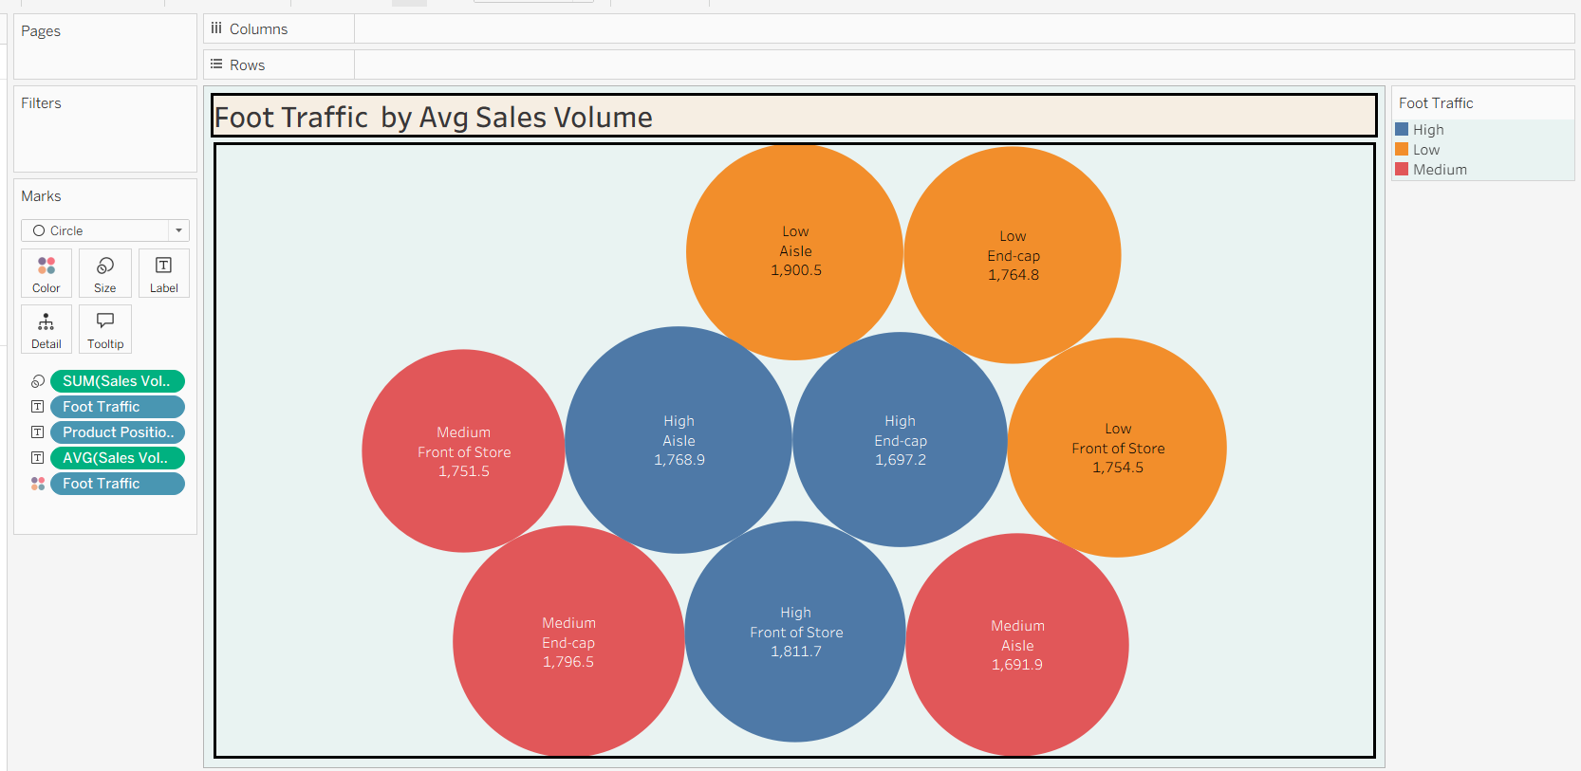
- Dashboard
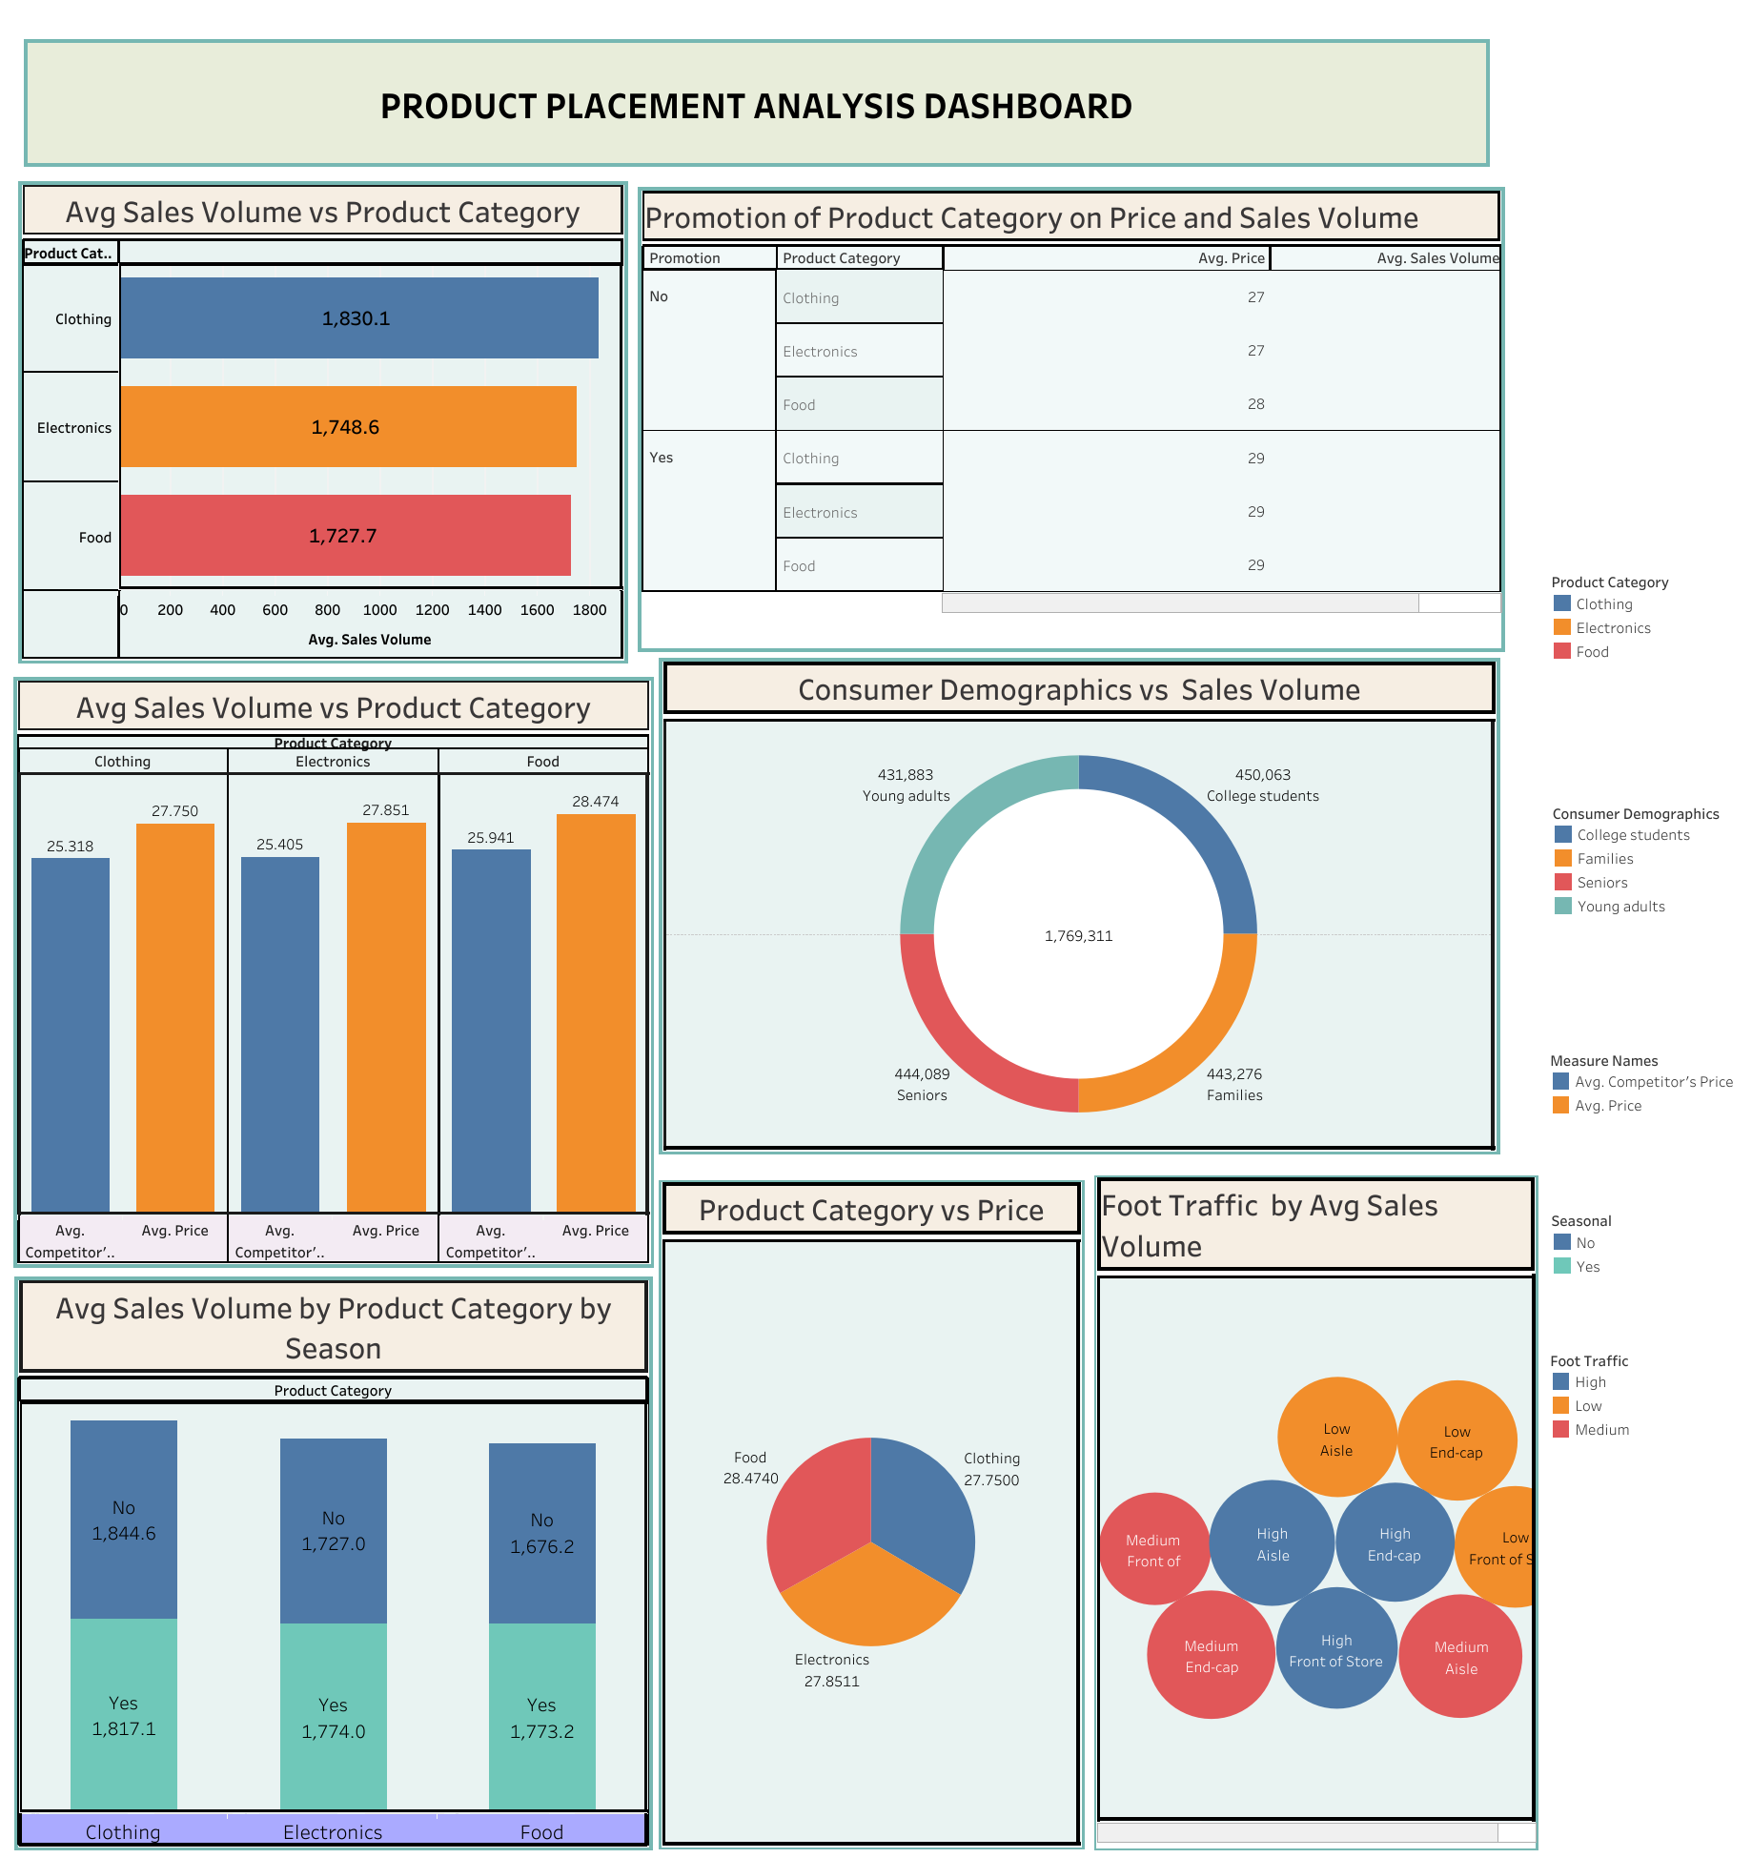

- Story
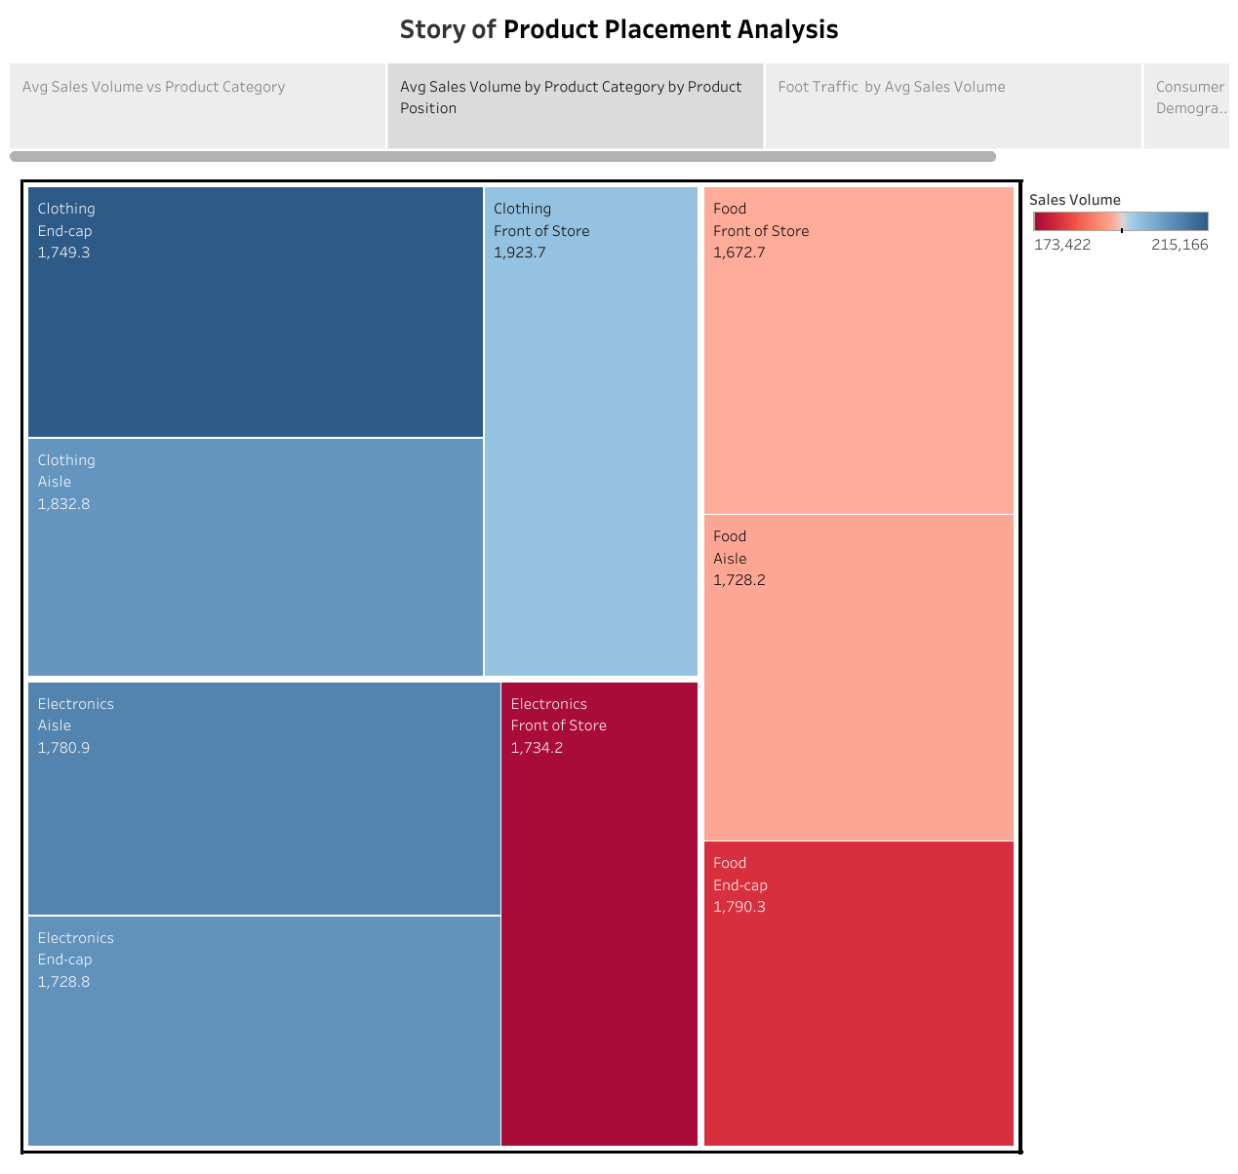
8. ADVANTAGES & DISADVANTAGES
- Advantages
- Easy interpretation of placement performance
- Centralized retail analytics
- Interactive and story-driven presentation
- Supports data-driven merchandising decisions
- Improves revenue optimization
- Disadvantages
- Requires Tableau knowledge
- Uses static datasets (if no live POS integration)
- Scalability may require cloud infrastructure
9. CONCLUSION

This project demonstrates how Tableau can transform raw retail sales and placement data into meaningful business insights. The dashboard simplifies complex datasets into interactive analytics, enabling stakeholders to monitor sales trends, evaluate shelf effectiveness, and optimize product placement strategies for maximum profitability.
10. FUTURE SCOPE

- Integrate real-time POS data
- Implement predictive sales forecasting models
- Add AI-based placement recommendation system
- Develop mobile-friendly dashboards
- Expand analytics to customer behavior and basket analysis

11. APPENDIX

Data set Link: - CSV file used in Tableau

https://drive.google.com/file/d/1vHDNGw130kbYUPj-wl4640x-cz5349GM/view?usp=sharing

Tableau Publish: -

- Dashboard:

https://public.tableau.com/views/PRODUCTPLACEMENTANALYSISDashboard/Dashboard1?:language=en-US&:sid=&:redirect=auth&:display_count=n&:origin=viz_share_link

- Story

https://public.tableau.com/shared/YK7C5X965?:display_count=n&:origin=viz_share_link

Project Demo: -

https://drive.google.com/file/d/1WYIUXBAlYbYGTUcm2jy5qtBJAD4M9_Wf/view?usp=drivesdk

